1. User will see the login screen with the option to create new User.

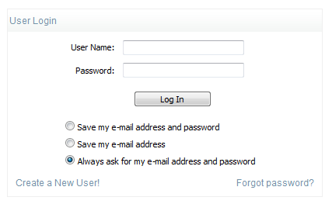

Secterate

seceratate

1. On clicking on Create new User / we will redirect the user to following page:- We would be asking for minimum information from registration area.

Registration Page will have following fields

Screen 1:-

Company info:- secreterate

|  |  |
| --- | --- |
| Company Name |  |
| Company Info |  |
| Company Country |  |
| Phone Number |  |
| Next Button | |

Screen 2:-

Primary Contact Info:-

|  |  |
| --- | --- |
| First Name |  |
| Last Name |  |
| Email Id |  |
| Password |  |
| Retype Password |  |
| Submit | |

Sending confirmation email to the user. As soon as the user click on the link his/her account will be activate and he/ she would be able to login.

1. On clicking forget password link we will redirect the user to forget password page.

|  |  |
| --- | --- |
| Enter Email Id: |  |

We will check whether the User with the provided Email exists or not. if exists we will send email with a link, which will be redirected to a page as below:-

|  |  |
| --- | --- |
| New Password |  |
| Retype Password |  |

1. User will be redirected to Application home page which will be designed based on the modules.
2. Employee Listing:-

+Add New Employee

|  |  |  |  |  |  |  |
| --- | --- | --- | --- | --- | --- | --- |
| **[ Check Box ]** | **Edit** | **Employee Name** | **Email** | **Role** | **Status** | **Phone Number** |
|  |  |  |  |  |  |  |

Delete Cancel

1. Clicking on the "Add New Employee" Button user will be redirected to the page that looks like this .















Save Cancel

7. Employee Details Page:-

Employee Name:- Sheesh Pal

Email:- sbhardwaj@mileston.us.com

Phone Number:----+91 86076-00020

Role: Employee

-----------------------------------------------------------------------------------------------------------------------------

Address Listing in the same(Emloyee Details Page)

Add Address (Link to add new address)

|  |  |  |  |  |  |  |
| --- | --- | --- | --- | --- | --- | --- |
| **[ Check Box ]** | **Edit** | **Street Address** | **City** | **State** | **Country** | **Zip** |
|  |  |  |  |  |  |  |

Add Address (Link to add new address)

|  |  |  |  |  |  |
| --- | --- | --- | --- | --- | --- |
| **[ Check Box ]** | **Edit** | **Country Code** | **Àrea Code** | **Phone Number** | **Extension** |
|  |  |  |  |  |  |

Clcking on the Add Address Page will look like this:-















Save Cancel

Add Phone will look like this:-





